**Must Be Santa**

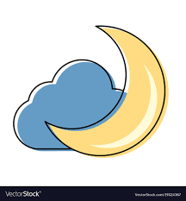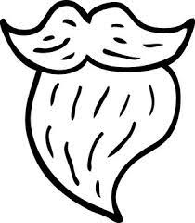Who's got a beard that's long and white?  
Santa's got a beard that's long and white  
Who comes around on a special night?  
Santa comes around on a special night

Special night – beard that's white

Must be Santa, must be Santa  
Must be Santa, Santa Claus

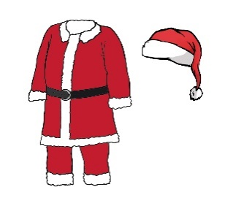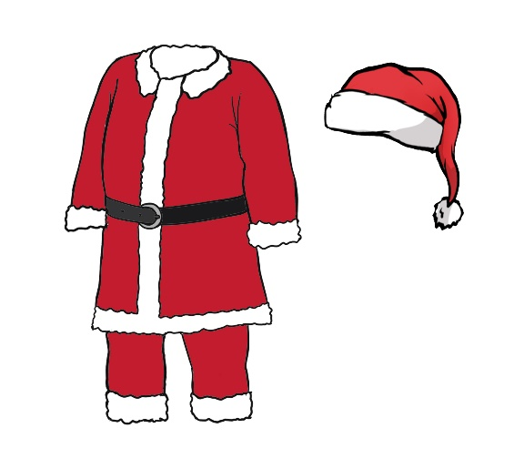Who wears boots and a suit of red?   
Santa wears boots and a suit of red  
Who wears a long cap on his head?   
Santa wears a long cap on his head

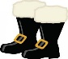Cap on head – suit that's red  
Special night – beard that's white

Must be Santa, must be Santa  
Must be Santa, Santa Claus

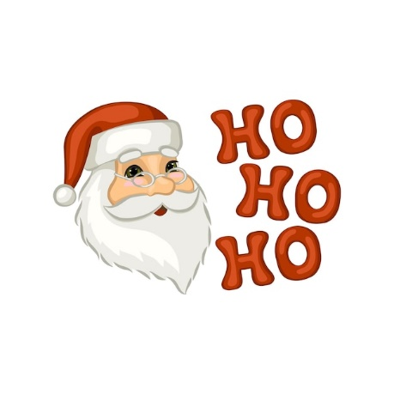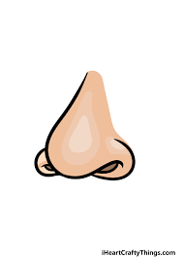Who's got a big red cherry nose?  
Santa's got a big red cherry nose  
Who laughs this way: "Ho-ho-ho"?  
Santa laughs this way "Ho-ho-ho"

Ho-ho-ho – cherry nose  
Cap on head – suit that's red  
Special night – beard that's white

Must be Santa, must be Santa  
Must be Santa, Santa Claus

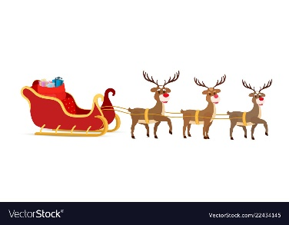Who very soon will come our way?  
Santa very soon will come our way  
Eight little reindeers pull his sleigh  
Santa's little reindeer pull his sleigh

Reindeer sleigh – come our way  
Ho-ho-ho – cherry nose  
Cap on head – suit that's red  
Special night – beard that's white

Must be Santa, must be Santa  
Must be Santa, Santa Claus

Must be Santa, must be Santa  
Must be Santa, Santa Claus

Must be Santa, must be Santa  
Must be Santa, Santa Claus